HansonHouse TBI Clubhouse

What is HansonHouse?

First and foremost, HansonHouse is a group of persons who support one another in living independent, productive lives following brain injury. Membership is voluntary. Clubhouse members and staff work together to make the clubhouse a reality and create meaningful activities and opportunities.

What Does HansonHouse Offer?

HansonHouse is a non-medical, community-based, organization that offers social, recreational, educational & occupational programming. HansonHouse offers:
- Friendship
- Prevention education
- Independent living skills
- Practice employment opportunities
- Annual summer, holiday events, golf league
- Personal, community, medical and legislative advocacy
- Caregiver Support Group
- Education to families, groups, organizations and
public servants regarding the special needs of
adults with brain injuries.

For more information:

HansonHouse TBI Clubhouse
173 Front Street
Berea, Ohio 44017
440-234-9900
tbidirector@aol.com
www.HansonhouseBerea.com
Visit us on Facebook and www.Guidestar.org

HansonHouse is a 501c3 not-for-profit organization and is
funded solely by private donations, fundraisers and small grants.



Briarwood Golf Club
June 15th, 2018
9am Shotgun start for golfers
230pm Banquet, Prizes, Auction
This tournament serves as a major fundraiser for the HansonHouse TBI Clubhouse. HansonHouse follows the “clubhouse model” of non-medical, long term support for people following brain injury. We thank you for your support and hope you will patronize and thank the major sponsors, business sponsors, and friends of HansonHouse listed in this booklet.



HansonHouse TBI
Clubhouse

GOLF RULES
This outing is a four-person scramble. Each golfer tees off, you select the best-shot and everyone moves his/her ball to that spot for the second shot and so on. Once on the green you must hole out the putt. You keep only one score for your foursome. Keep a written score on the scorecard. Do not score each player. Team prizes will be awarded based on scores. Men tee from WHITE tees, Women from the RED Tees, and seniors (65 & over) may use the GOLD tees. Any team not having four persons may take a fourth shot on each hole by rotating the shot between those players on the team. Each person in the foursome and/or threesome must use their drive at least once per 9 holes. No exceptions.
Mulligans FOR SALE at registration
$20 per team (3 or 4 golfers)

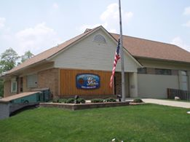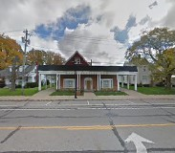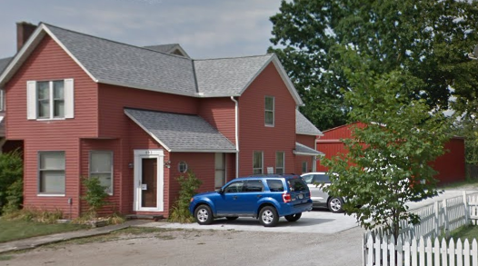


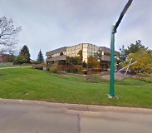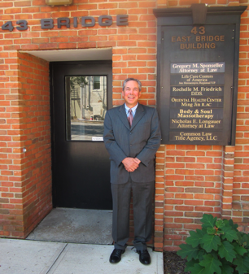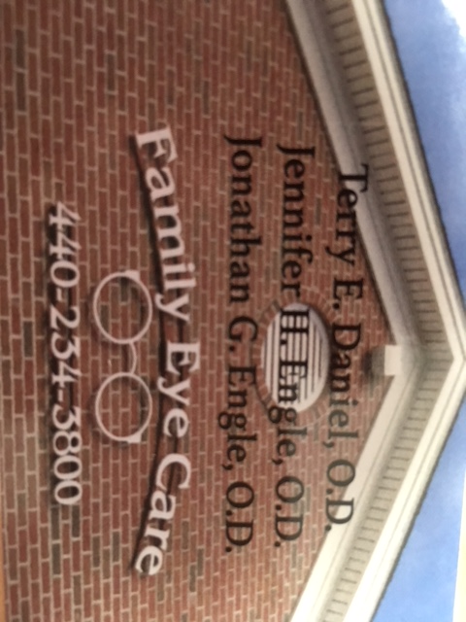

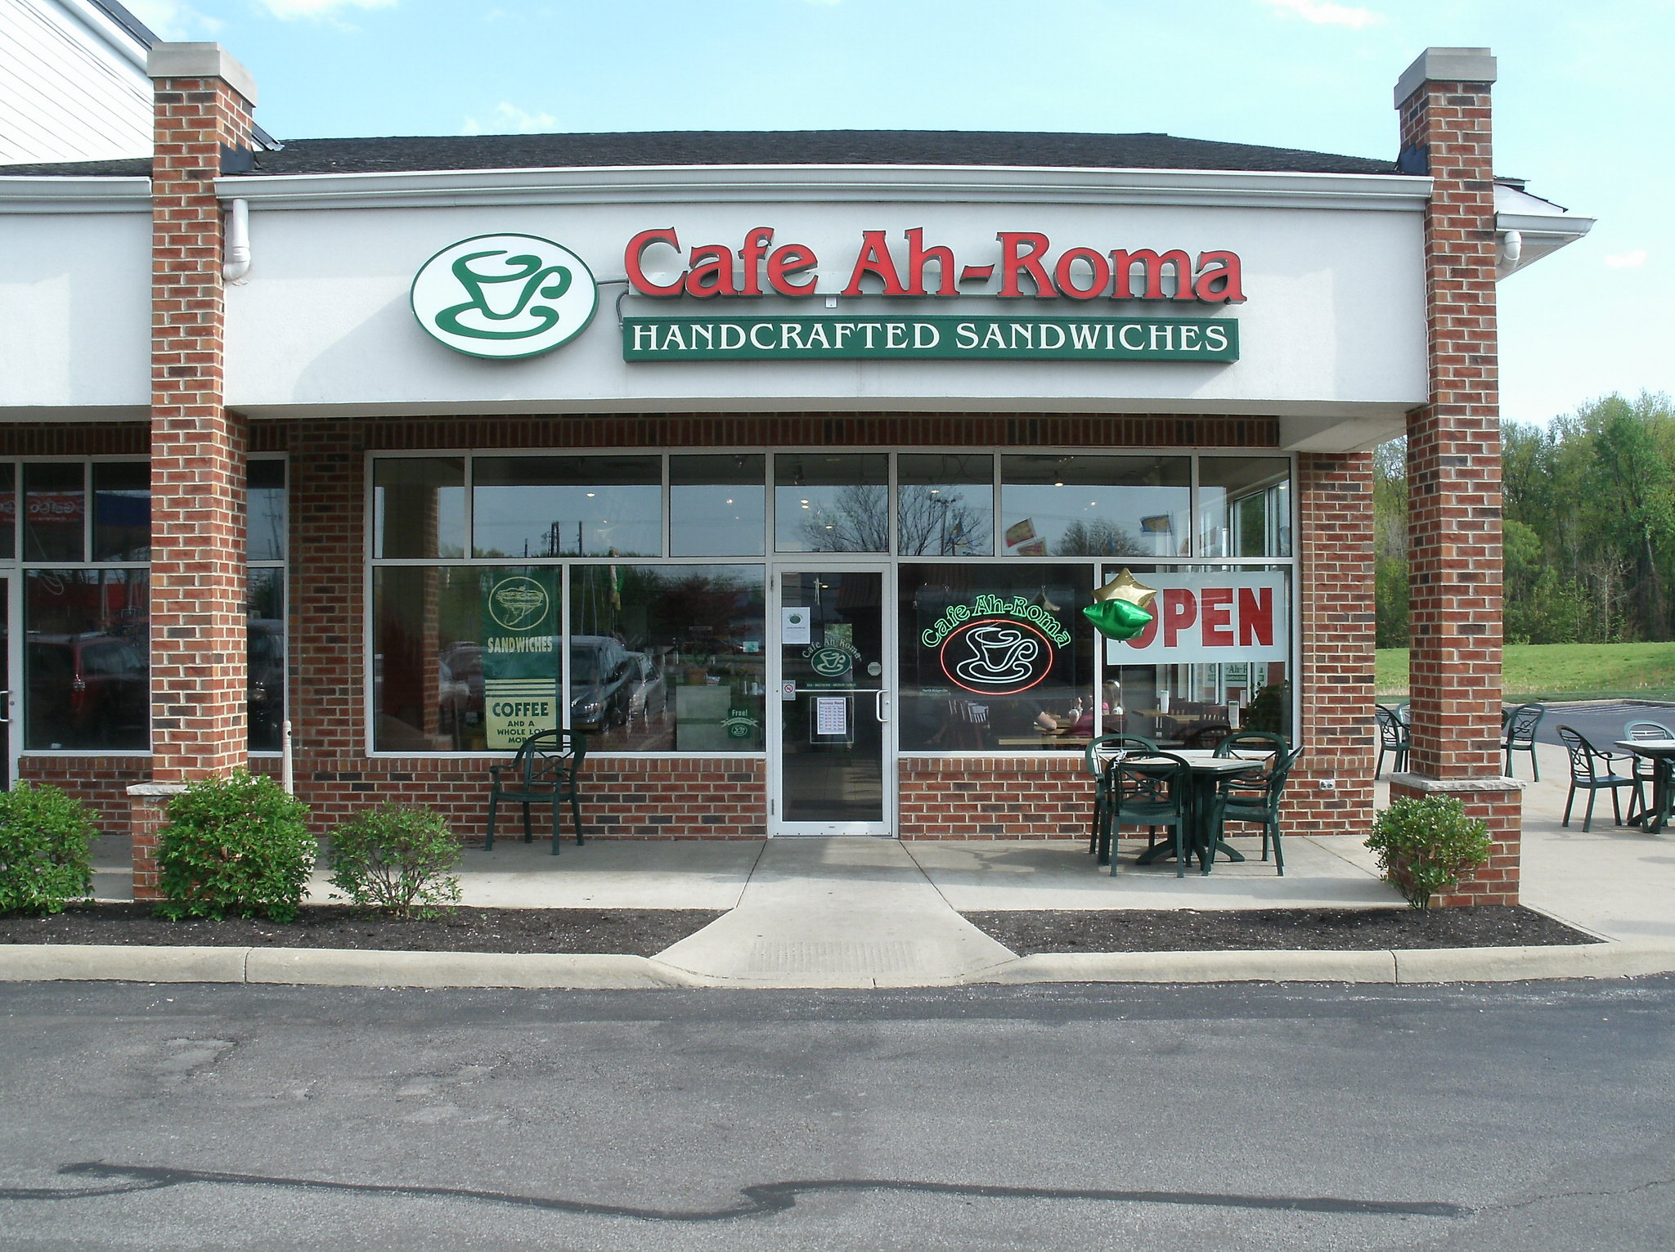

FRIENDS OF HANSONHOUSE 125+

Larry and Elaine Myers Jeff and Jeanne Haas
Barbara Wilson Kristi Boggs
John Haight George and Joelyn Richards
Don and Ruth Hagen John and Barb Fehl

HANSONHOUSE BUSINESS SPONSORS 125+
American Legion Post 91 Berea
American Legion Post 91 Auxiliary
American Legion Post 91 Sons

Baker, Osinski, Kensinger Funeral Home
206 Front Str. Berea 440-234-1331

Berea City Club, Inc.

Berea Midpark High School Athletic Boosters
Brennan Electric
493 Front Street Berea 440-243-9100

Café Ah-Roma
Colony Roofing
951 W. Bagley Rd. Berea 440-826-3444

Elegant Embroidery
1053 Prospect Rd. Strongsville 440-878-0904

Family Eye Care Drs. Daniel and Engle
295 High Street Berea 440-234-3800

J & J Appliances
760 N. Rocky River Dr Berea 440-243-1844

Kiwanis Club Brecksville
Kiwanis Club Brooklyn-Cleveland
Kiwanis Club Independence
Kiwanis Club Strongsville
Kiwanis Club North Royalton

Parkway Barber Shop
42 W. Bridge St Berea 440-234-5106
Charlotte Garmon

Gregory Sponseller, Attorney At Law
43 E Bridge St #101, Berea 440-826-4114

Sylvesters Auto and Light Truck
Chris Sylvester and Rich Dunn, Owners
356 W Bagley Rd 440-234-2580

Serpentini Collision Center
520 Front St Berea 440-234-3001

Strongsville Psychological Services
Al Klubert 14843 W. Sprague Road Suite A
Strongsville 440-234-9955

Contests

Skins Game:

Each foursome has the opportunity to win cash by signing up at registration. Entry fee into the Skins Game is $20 per team of 3 or 4 golfers. All skins proceeds will be distributed to the winner. In the event there are no skins, the proceeds will remain with HansonHouse.

Putting Contest:

8am – approx.230pm Top 5 meet at 3pm for Putt-Off
$5 for three balls
Putts will be made from the line marked at 25ft. The closest of the 3 tries will be recorded.
You may enter as many times as you like up thru the end of play. (when all golfers have returned to clubhouse)
The top 5 contestants will have a “putt-off” with 1 ball.
Top 3 will receive 30/20/10% of pot with remaining 40% to HansonHouse. 4th and 5th place-small gift.

Closest to the Pin
$10 to participate, pay at Registration and receive official recording paper to be returned at end of play before banquet. Tee off, ball must land on the green. Record distance from front edge of ball to cup, sign and return at end of play. Place measuring tape in cup. Winner takes 50% of pot. Ties will split the 50% of pot equally.

Team Scramble Winners:

Cash prizes ($60/40/20) will be given to the 1st, 5th and 10th place teams. Ties will be broken by comparing hole scores beginning with #1 Handicap hole and working backwards.

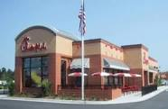
Chicken Sandwiches provided by:
Chick-Fil-A
North Olmsted

Muffins prepared by The Members of HansonHouse
Coffee provided by:
Café Ah-Roma
Berea Parkway Shops
Rob and Mary Bennet

Important Information

Coffee and muffins at the greeting area

Receive your starting hole number at the registration area

If your cart breaks down call 440-237-5271

First Aid Kit at the registration desk if needed, otherwise call 911.
Inform the ranger of your 911 call.

In case of cancellation notify, in writing, the amount you would like refunded to: HansonHouse, 173 Front St, Berea, OH 44017

Items Donated by
Friends of HansonHouse:

Pete Martin – Ameripack
Paul Richards
Bob Norton
Jobette Sechler Earthly Treasures Ministry
Claire Kapitan Artist
Chris Lobas Architect and Artist
Be Safe Love Mom When you enlist in the United States Military, you don’t just sign yourself up for years of duty, you also commit your loved ones to a life of service all their own.
Anita Ferut
Grace Ferut
Baldwin Wallace University
Mentis
Tony Dick

Other Monetary Gifts:

Judy and Steve Taylor
Marty and Michelle McGinty
JM and Stephanie Lanier
Jobette Sechler and Earthly Treasures Ministry

Dinner served and prepared by
Elegant Affairs
Alfonso’s Catering
HAVE A GREAT DAY
PLAYING
THE GAME YOU LOVE FOR
THE BENEFIT OF OTHERS

Other Fun

50/50 Raffle $5.00 / ticket

Chinese Auction $1.00 per ticket or 6 for $5, 15 for $10, 35 for $20

Silent Auction: Make your bid on some great gifts. Minimum bid requested on some items.

Raffle Cole Haan Leather Tote (14 inch)
Retail $368 $20.00 per chance $50 for three

Raffle and Auction Items:

Items Donated by:

Golf Courses:

Creekwood
Royal Crest
PineBrook
Mallard Creek
Briarwood
Dragon Ranch
Oaks Gof
Hickory Nut

Professional Sports Groups:

Cleveland Cavaliers
Cleveland Monsters
Cleveland Browns

Veteran Honors
and

Veteran Honors
and
Memorial Holes

Please observe the organizations and families that have donated $500+ to honor United States Military members or a loved one.

Honoring ALL our
Military Men and Women:

VFW Strongsville Post 3345
Southwest General Health Center
Southwest Family Physicians

In Memory of Pat and George Ferko
Pattie and Maureen Ferko

In Memory of Helen Mallarnee –
Roy Mallarnee and family

In Memory of Linda Short, Bill Barber,
George Toth, and Jodee Ward–
Kiwanis Club of Berea

In Memory of Frances Kovalsky
Grindstone Awardee Jeff Haas and
Berea Chamber of Commerce

Major Sponsors


The United Methodist Church of Berea

Kiwanis Club of Berea

Kiwanis Division #24
City of Berea
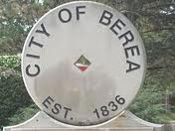


RWS Foundation
Boggs and Ferut Family
