Briarwood Golf Club
Golf Outing Packet

2737 Edgerton Road
Broadview Heights, Ohio 44147
440-237-5271
Briarwood Golf Club and Event Center

Event Details

Briarwood Golf Club is the perfect location for your special event. Located in the rolling hills of Broadview Heights, nature provides a beautiful backdrop. We are available for events ranging from wedding ceremonies and receptions, baby and wedding showers, birthday/ anniversary parties and more! Whatever your special event needs are, we would love to help. Our staff is warm and welcoming and will provide expert attention to make sure your event is perfect.

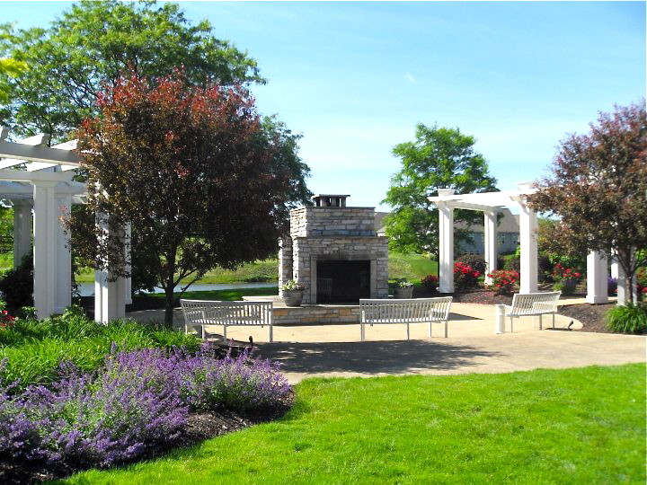

Elegant Affair’s
Dave Epifano 440-821-6145
Dfepinnacle@yahoo.com

General Information

Contract Guarantee
A guaranteed number of guests will be required no later than 7 days prior to the scheduled event. No allowances will be made for any decrease in guaranteed guest count. Should, for any reason, actual attendance be less than 80% below initial booking amount, an additional fee will be assessed.

Payment information
After the final confirmation of guests attending (7 days prior to event), we will present you with a total. We ask that payment is made at this time (5 days prior to your scheduled event).

Any payments to Briarwood Golf Club may be made by cash, check, Visa, MasterCard, American Express, or Discover Card. We do not offer house accounts or direct billing.

At the conclusion of your event, you will be presented with a final bill for any additional charges incurred that day (i.e. bar costs, menu changes).

8% Ohio Sales Tax, when applicable, and 20% Service Charge is applied to all menus. If your organization is Tax Exempt, please provide your event coordinator with your tax exempt number prior to your function.

Elegant Affair’s Catering reserves the right to make room reassignments if a substantial fluctuation in your head count occurs.

Liquor Policy
As part of our liquor license, all alcohol must come through Briarwood Golf Club. Briarwood Golf Club reserves the right to refuse bar service and dismiss any guests who appear to be intoxicated or disruptive.

Food Policy
We do not allow any food outside of Elegant Affair’s Catering, with the exception of a wedding cake, to be brought into our serviced functions. We are more than happy to accommodate any special dietary needs and will work with you to create a custom menu for your event. If left over food is available at the end of your event, we are happy to package this up for you to take home, however it is not a guarantee that there will ever be extra to take home.

Children’s Menu Pricing
Elegant Affair’s Catering does offer special pricing for children. Children under 3 are free of charge, while children 4-12 years of age are $10.00. They have the option of eating from the buffet, or choosing chicken tenders with French fries. Please let us know if you plan to have children attend your event and what their menu choice will be.

Payment Terms:
Event Rules and Regulations
Final guest count will be provided 7 days prior to your event. The remaining balance will be due five (5) business days prior to your event, no exceptions. Payment may be made in the form of Credit Card, Cash or Check to Briarwood Golf Club. After payment is made, your final count cannot go down, but can go up if needed.

Room Set-up:
The timing of the set-up of the room for an event is dependent on what events are happening that week and are at the discretion of the Briarwood staff. We will do our best to accommodate, but it is not a guarantee that you may be able to set up, or decorate in the banquet room prior to the day of your event. Please schedule a time to decorate with our event coordinator. All set up of additional decor, including using outside centerpieces, flowers, etc. is the responsibility of the party who has booked the room and not our staff. In some situations, we may be able to assist with favors, however please discuss this with our event coordinator prior to the day of your event. All decor, including items hung from the walls, must be approved by our event coordinator. We are not able to store any decorations prior to the event. It is part of the agreement, that arrangements must be made for all extra decorations to be removed from the premises at the end of your event. In the event that a 2nd bar is used for your event and planned for outdoors, it is at the discretion of Briarwood’s staff, on whether the set-up needs to be brought indoors, due to weather or climate the day of your event.

Room Rental:
The hours of the room rental will be decided prior to the event, based on which package is chosen. All vendors, including DJ, should be made aware and scheduled within the timing allotted for the room rental. Clean up of the room including decorations are expected to be completed by the time written in the final contract. The room should be vacant within 45 minutes of the reception end time, so please make arrangements prior. Your DJ and bar should coordinate together with your reception end time.

Vendors:
Vendor set-up times must be discussed and cleared with the Briarwood staff. A vendor itinerary must be presented to the event coordinator 3 days prior to your wedding for approval. Your cake is to not be delivered more than 3 hours prior to your event and should be set up by your vendor. Briarwood is not responsible for the cooling and setting up of your cake. If you plan to use our grounds for pictures, please discuss the locations with our event coordinator prior.

Liability:
Briarwood is not responsible for the loss of personal articles and does not claim responsibility for gifts, cards or items brought to an event. You will be responsible for any damage inflicted to the building, property or grounds during the time of your event.

Cancellation:
You have 45 days from the time you give your deposit to cancel with us and get your deposit back. After the 45 days, your deposit will be non-refundable. Cancellations made within 30 days of actual event date will not receive the deposit back.

Services and Fees

Standard Services
(Included)

All banquet round tables
Classic linens in white, or ivory
Napkin color of your choice (included with buffet packages)
Classic Centerpiece
Cutting and plating of your cake (included with buffet packages)
Free parking

Additional Services
(Additional charges apply)

Premium linens in color of your choice (price dependent on color)
Signature Centerpieces ($5 per table, $1 per votive)
Chair covers with sash ($4.50 per chair)
Table Sashes ($4.00 per runner and up)

Rental Fees

Room fee
75 or more guests room fee of $250
50-74 guests room fee of $200
25-50 guest room fee of $150

Briarwood Golf Club & Event Center

Golf Outings

Cleveland’s Elegant Affairs Catering

Our Mission
We will provide you and your guests with the best possible catering experience and event execution period!

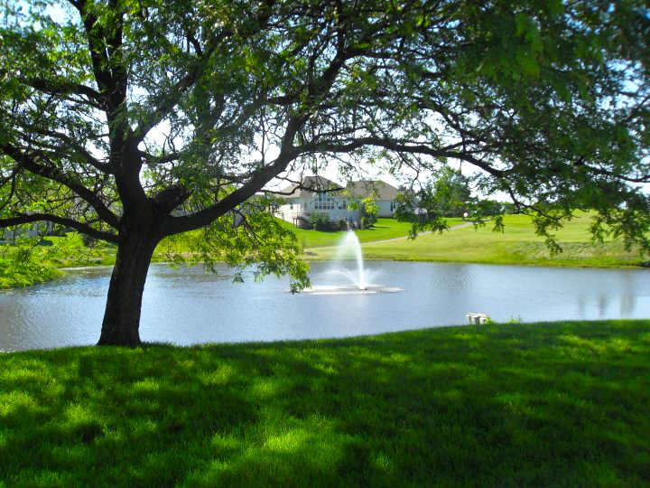

2737 Edgerton Road
Broadview Heights, Ohio 44147
General Information
A guaranteed number of guests will be required no later than 7 days prior to the scheduled event. No allowances will be made for any decrease in guaranteed guest count. Should, for any reason actual attendance be less that 80% below initial amount, an additional fee will be assessed.

Payment Information
Cash, check, Visa, MasterCard, American Express, or Discover Card can make any payments, We do not offer house account or direct billing.

8% Ohio Sales Tax, when applicable, and 20% Service Charge is applied to all menus. If your organization is Tax Exempt, please provide your event coordinator with your exempt number prior to your function.

Elegant Affair’s Catering reserves the right to make room reassignments if a substantial fluctuation in your head count occurs.

All pricing represents full service, which includes set up, clean up, white, black, or ivory linen table clothes, china, and Glassware and service personnel when applicable.

Menu and Food Policy
Our menu is provided exclusively through Elegant Affair’s, a long-standing tradition of providing excellent food and service, Alfonso’s Catering is the perfect choice for your event. The following items are designed to assist in planning your event. Sample menus and policies are enclosed. Please feel free to inquire about additional options.

Golf Outings
The price per person includes all set up, service personnel and sales tax. The finest Disposable Plastic ware available can be rented with an additional $400.00 room charge.

Elegant Affair’s Golf Outing Menu: Eagle Package

Combination of lunch and dinner: $30.00 per person
(All items are grilled on premise)

Lunch (Select one)
Angus Burger W/ relish Trays
Italian sausage and peppers w/ relish trays
All beef hot dogs w/ relish trays
Served with assorted chips

Dinner (Select one)
Center cut strip steak
Fresh grilled chicken
St. Louis Ribs
Herb Roasted bone in chicken

Sides (Select three)
Herb seasoned roasted red skin potatoes
Rotini w/ house made tomato or marinara sauce
Unbelievable Pasta Salad
Green bean almandine
Corn on the cob
Baked Beans
Fresh Field greens w/ house Italian dressing
Caesar Salad
Wild Rice
Parsley buttered red skins
Coleslaw
Corn O’Brian

Menu Pricing includes sales tax, gratuity & non-alcoholic beverages

Breakfast Package’s

Continental
$10.00 per person
Fresh assortment of homemade muffins,
Sweet breads, Danish and bagels including jams,
Cream cheese and whipped butter.
Fresh seasonal fruit
Assorted juices
Coffee and tea
Includes plastic ware

All American Breakfast 1
$17.00 per person
Scrambled eggs
Crisp bacon, link sausage, or honey ham
Breakfast potatoes
French toast with maple syrup and whipped butter
Assortment of Danish, sweet breads, muffins and bagels
Fresh seasonal fruit
Assorted juices
Coffee and tea
Includes plastic ware

All American Breakfast 2
$17.50 per person
Fresh seasonal fruit
Assorted juices
Coffee and tea
Includes plastic ware

Beverage Service

Domestic Keg Beer
½ Keg: $155.00
¼ Keg: $100.00
(Prices May Vary)

Beverage Cart
Includes but not limited to:
Assorted sodas, Gatorades and Bottled Waters
Domestic and Imported Beers

